

AHMAD NUR CAHYADI

190511094 / R3

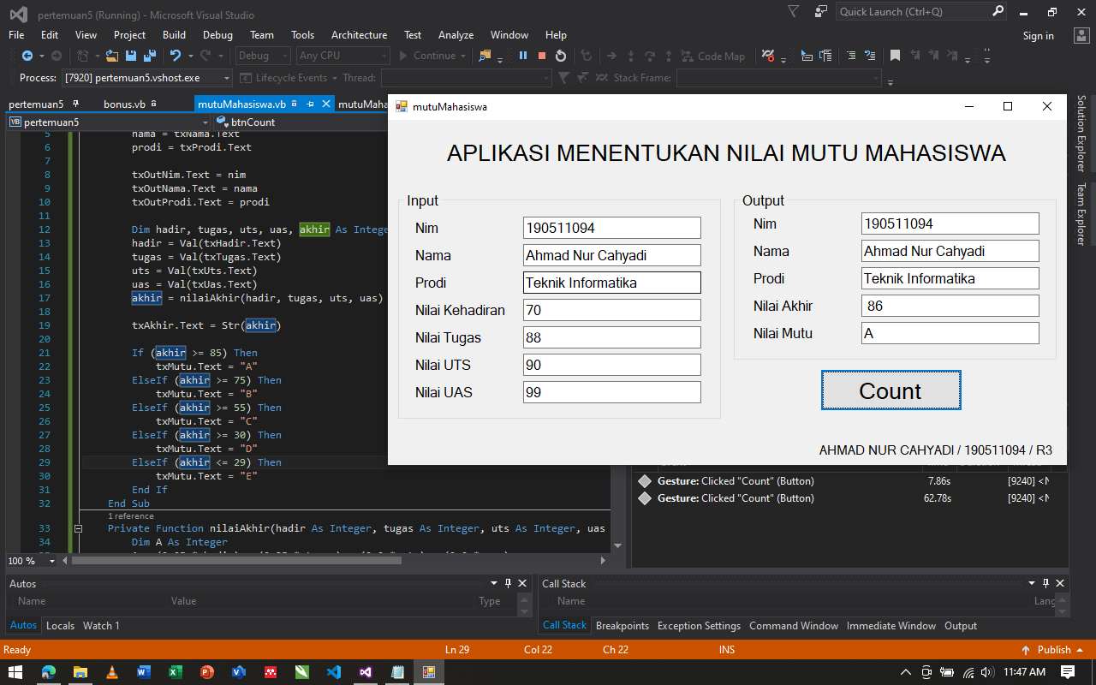

Source Code nya :

Public Class mutuMahasiswa

Private Sub btnCount_Click(sender As Object, e As EventArgs) Handles btnCount.Click

Dim nim, nama, prodi As String

nim = txNim.Text

nama = txNama.Text

prodi = txProdi.Text

txOutNim.Text = nim

txOutNama.Text = nama

txOutProdi.Text = prodi

Dim hadir, tugas, uts, uas, akhir As Integer

hadir = Val(txHadir.Text)

tugas = Val(txTugas.Text)

uts = Val(txUts.Text)

uas = Val(txUas.Text)

akhir = nilaiAkhir(hadir, tugas, uts, uas)

txAkhir.Text = Str(akhir)

If (akhir >= 85) Then

txMutu.Text = "A"

ElseIf (akhir >= 75) Then

txMutu.Text = "B"

ElseIf (akhir >= 55) Then

txMutu.Text = "C"

ElseIf (akhir >= 30) Then

txMutu.Text = "D"

ElseIf (akhir <= 29) Then

txMutu.Text = "E"

End If

End Sub

Private Function nilaiAkhir(hadir As Integer, tugas As Integer, uts As Integer, uas As Integer) As Integer

Dim A As Integer

A = (0.25 * hadir) + (0.35 * tugas) + (0.2 * uts) + (0.2 * uas)

Return A

End Function

End Class